CL 2006 OPERATING SYSTEM

BS Software Engineering

Course Instructors: Syed Daniyal Hussain Shah, Hifza Umar



Lab 09: Dup System Calls
The dup and dup2 system calls in Linux are used to duplicate file descriptors.

dup System Call:
The dup system call duplicates an existing file descriptor.
The new file descriptor returned by dup is the lowest-numbered unused file descriptor.
Both file descriptors (the original and the new one) refer to the same open file description, so they share the same file offset and file status flags.

Syntax:
int dup(int oldfd);

Example:
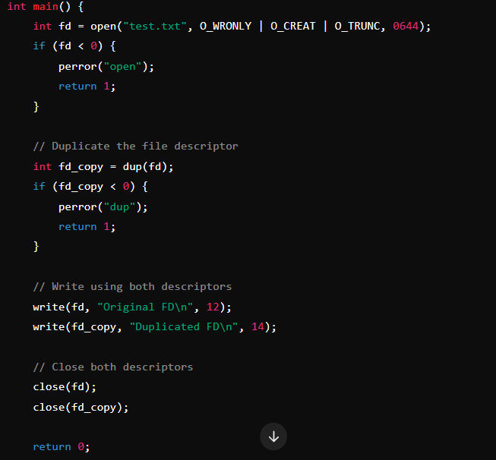
The program opens a file test.txt with write access.
It duplicates the file descriptor using dup, creating a new file descriptor (fd_copy).
Both fd and fd_copy refer to the same file, so writing through either affects the file.
The file is written using both descriptors.
Both descriptors are closed.

Output:
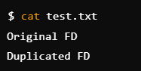

dup2 System Call:
dup2 allows you to specify the new file descriptor. It duplicates the first file descriptor into the second file descriptor.

Syntax:
int dup2(int oldfd, int newfd);

Example:
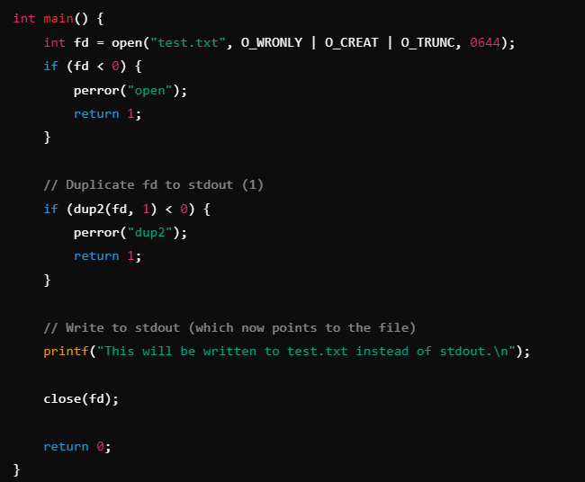
The program opens a file test.txt for writing.
It uses dup2 to duplicate fd onto stdout (file descriptor 1). 0 is for stdin (Standard input i.e keyboard), 1 for stdout (Standard output), 2 for stderr (Standard error).
Any write to stdout (like printf) will now go to test.txt instead of the terminal.
The output is redirected to the file.
The dup2(fd, 1) command duplicates the file descriptor fd onto file descriptor 1, which is normally stdout. This means any output that would normally go to the terminal (stdout) will be redirected to the file represented by fd.

Output:
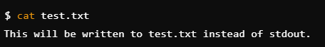
In dup2(fd, X), the second argument (X) can be any valid file descriptor. Here are the common values you might use:

Common File Descriptors:
0 – Standard Input (stdin): Normally, this reads input from the terminal. If you redirect this to a file using dup2(fd, 0), the file will become the input source.
1 – Standard Output (stdout): Normally, this outputs to the terminal. Using dup2(fd, 1), you can redirect the output to a file.
2 – Standard Error (stderr): Normally, error messages go to the terminal. You can redirect errors to a file using dup2(fd, 2).

Example using stdout and stderr:
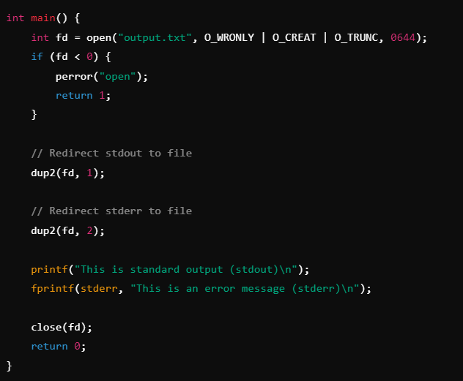
dup2(fd, 1): Redirects standard output to the file output.txt.
dup2(fd, 2): Redirects standard error to the same file.

Output in output.txt file:
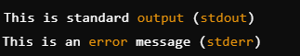
Both the standard output and the error message are written to output.txt instead of the terminal.

Example: Redirecting stdin from a File:
This example opens a file for reading and then uses dup2 to redirect stdin so that when you use functions like scanf or fgets, the input comes from the file instead of the keyboard.
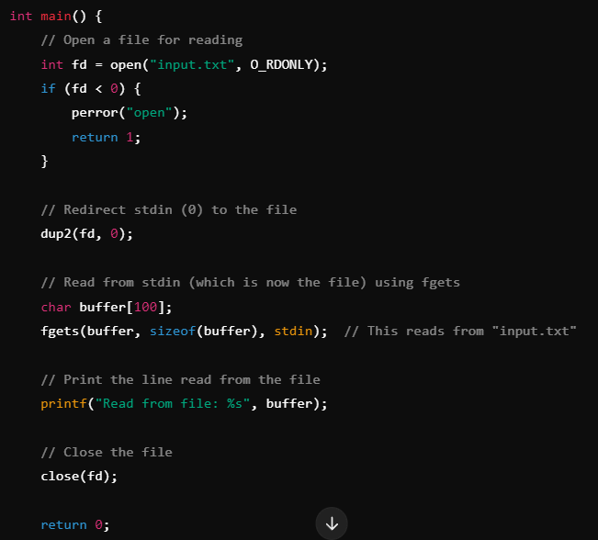
The program opens a file called input.txt in read-only mode.
dup2(fd, 0) redirects the standard input (file descriptor 0) to the file.
fgets(buffer, sizeof(buffer), stdin) reads from the file instead of the terminal.
The program prints the content it read from the file.

Contents of input.txt:


Output:

When the program reads from stdin, it actually reads from input.txt because of the redirection with dup2(fd, 0).
The file's content (Hello, world!) is read and then printed to stdout.

Tasks:

- Use dup() to duplicate a file descriptor for a file, store it in a variable fd_dup, then use fd_dup in dup2() to copy it into stdout and redirect the output of printf to the file. It means if we write printf(“Helllo world”); then it should not display on terminal but instead it should be written into file.

- Use dup2() to duplicate the file descriptor for stdin, so input can be taken from a file instead of the terminal.
Use fgets(buffer, sizeof(buffer), stdin);
Usually when we use fgets(buffer, sizeof(buffer), stdin); then it takes input from stdin which is set to keyboard so it takes input from keyboard and stores it in buffer variable but when you duplicate the file descriptor of a file into stdin then it will take reads data from a file and stores it in buffer.

- Redirect stderr to a file using dup()2 and simulate an error message.

- Use unnamed pipe to send data from child to parent and parents then prints it. Don’t use write() system call instead use printf so that if you write printf(“Messagge from child”); then it shouldn’t be displayed on console but is should be written into write end of unnamed pipe and parents then reads it using read end of pipe and displays it on console.

Task Submission Guidelines:
- Make a document and paste all tasks solution there (Not screenshot) and save it as pdf.
- Along with each task solution, also upload the screenshot of the output.
- Include your name and roll no. at the front page.
- Please submit your file in this format (Roll_number-name) i.e (24I-1234-Ali.pdf).
- Files other than pdf will not be accepted and will be marked as 0.

